LCBC – Lorain County Bicycle Club
January 2024 Newsletter
Happy New Year to All

As we begin the new year, let’s review the past year. Over the years, the members have kept track of their annual mileage and many eclipsed the 4,000 mile mark with the top riders going over 5,000 and even 6,000 miles during the season. 2023 began with high hopes to equal or exceed the past years’ totals but weather and health issues dashed those goals. In 2023 a solid group of riders rode around 3,000 miles with the club and Karla and Ralph totaled over the 3,000 mark. Other riders made it over that number by riding Zwift or on non-club rides, among them were John who went over the 4,000 mark and Lynn who made it past the 3,000 mark.

The core club members remained dedicated and the group rides were spirited (but maybe a bit slower than in the past). Thanks so much to Karla, Karen, and Louise who served as president/secretary, vice president/Red Flannel coordinator, and treasurer this year for their leadership. Also thanks to our road captain, Clyde, and our webmaster, Nancy. There was a lot of behind the scene planning which helped us end the season with a great Red Flannel; good weather helped as well. The non-supported club rides were another story. The AFROST ride was a complete washout both literally and figuratively with no club members riding and only five guests venturing out into the rain. The JJJ was a bit better but only one club member rode the century with most opting for the 50 mile route. The weather was good and a total of 20-30 riders (including guests) tackled one of the two routes. The Roast Your Buns August ride boasted good weather and the turnout was moderate but most club riders opted for one of the shorter routes which led to several guests getting lost on the long route.
The riding year ended this New Year’s Eve on a chilly (36 degrees), drizzly day. Four riders braved the elements and made it to Sterks in Wakeman. I rode too but turned around ten miles into the ride.
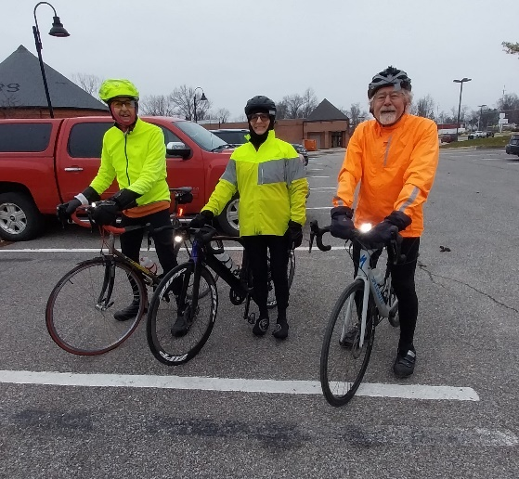Clyde, Karla, and David on NYE – Marc joined the ride a bit after the picture was taken.
Now to 2024! It is time to make some resolutions. Here are some cycling related ideas.

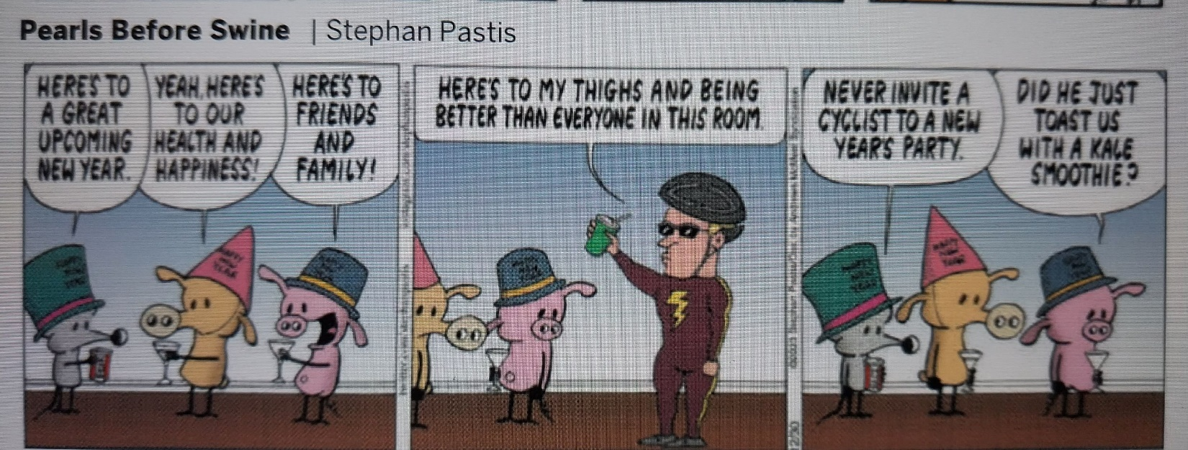

- Resolve to ride more often with the club. You can be social or quiet as your spirit moves you but do show up. The larger the group the more the enjoyment. You can also bring fellow riders who need electric bikes.
- Set a mileage goal. Make it challenging but realistic.
- Use the winter months to get your bike in shape. If you are not a mechanic, spend the money and have the Oberlin Bicycle Shop or Century Cycles tune your bike up. Both have winter tune-up specials.
- Resolve to attend club meetings and to volunteer for at least one project. Spreading out the duties makes light work for all.
- Invite a friend to join you on one of your club rides. If you don’t have any friends who aren’t in the club, spot a cyclist out on the road and ask her/him to join us.
- Get yourself in shape. Find a workout program and diet that complements cycling so you are in the best shape you can be overall.

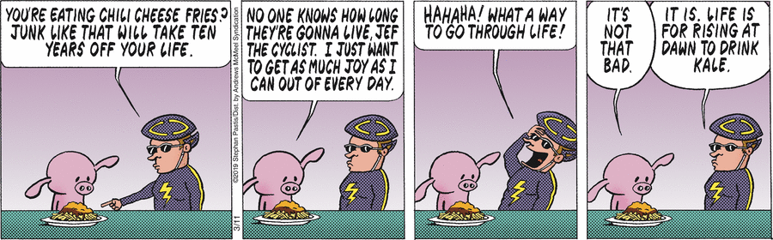

- Enjoy life! It is too short to not have fun!

It is also important to pack tools and tubes on your bike and, as the picture below illustrates, it may be vitally important to cycle with fellow club members – just count the number of tubes needed to fix a flat on this December ride.
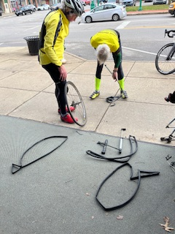(Editor’s note: I tried for 30 minutes to rotate this picture but it refused to cooperate. It is right in the folder but copies rotated. You can still count the tubes.)

President’s Corner
Goals
I am finding out some lovely things about being part of a club. I set a 3,000 mile Strava goal for 2023. Now that shouldn't have been too hard, but I'm a procrastinator. So there I was two weeks ago with an attainable goal, but it's the end of December in northern Ohio. As Shane put it to me this morning, "You know we wouldn't have to be out here if you had put a few more miles on last summer". Yep. I cannot deny my stupidity. But over the past two weeks I have had many club members willing to ride in crappy weather and on Holidays. You all are the best. Special kudos to Clyde and David, Steven, Denny, Shane, and Bill. This is why we ride with a club. People are there when you need them.
Also,
Karen and I made a somewhat executive decision to remove the AFROST (end of April) ride from the Ohio Ride Calendar. That has been a poorly attended, bad weather ride for a few years. So bad that club members rarely show up. So we may want to ride it as a club, but it won't be on the public Ohio ride calendar this year.
Lastly,
Happy new year to you all. Set some goals (and try to meet them early!). Watch your email for an announcement about the January club meeting. We are looking at a Tuesday; either the 9th or the 16th. Let me know if you have a preference.
Karla

Lorain County Bicycle Club

 | January 2024
Sun | Mon | Tue | Wed | Thu | Fri | Sat
31 | January 1  New Year's Day | 2 | 3 | 4 | 5 | 6
9 am  U-show 32 miles. Start at Oberlin Gasholder Building, 291 South Main Street, Oberlin, OH 44074 |  | 11 am  30 miles. Start at Oberlin Gasholder Building, 291 South Main Street, Oberlin, OH 44074 |  | 11 am  30 miles. Start at Oberlin Gasholder Building, 291 South Main Street, Oberlin, OH 44074 |  | 9 am  U-show 32 miles. Start at Oberlin Gasholder Building, 291 South Main Street, Oberlin, OH 44074
7 | 8 | 9 | 10 | 11 | 12 | 13
9 am  U-show 32 miles. Start at Oberlin Gasholder Building, 291 South Main Street, Oberlin, OH 44074 |  | 11 am  30 miles. Start at Oberlin Gasholder Building, 291 South Main Street, Oberlin, OH 44074 |  | 11 am  30 miles. Start at Oberlin Gasholder Building, 291 South Main Street, Oberlin, OH 44074 |  | 9 am  U-show 32 miles. Start at Oberlin Gasholder Building, 291 South Main Street, Oberlin, OH 44074
14 | 15  Martin Luther King Day | 16 | 17 | 18 | 19 | 20
9 am  U-show 32 miles. Start at Oberlin Gasholder Building, 291 South Main Street, Oberlin, OH 44074 |  | 11 am  30 miles. Start at Oberlin Gasholder Building, 291 South Main Street, Oberlin, OH 44074 |  | 11 am  30 miles. Start at Oberlin Gasholder Building, 291 South Main Street, Oberlin, OH 44074 |  | 9 am  U-show 32 miles. Start at Oberlin Gasholder Building, 291 South Main Street, Oberlin, OH 44074
21 | 22 | 23 | 24 | 25 | 26 | 27
9 am  U-show 32 miles. Start at Oberlin Gasholder Building, 291 South Main Street, Oberlin, OH 44074 |  | 11 am  30 miles. Start at Oberlin Gasholder Building, 291 South Main Street, Oberlin, OH 44074 |  | 11 am  30 miles. Start at Oberlin Gasholder Building, 291 South Main Street, Oberlin, OH 44074 |  | 9 am  U-show 32 miles. Start at Oberlin Gasholder Building, 291 South Main Street, Oberlin, OH 44074
28 | 29 | 30 | 31 | February 1 | 2 | 3
9 am  U-show 32 miles. Start at Oberlin Gasholder Building, 291 South Main Street, Oberlin, OH 44074 |  | 11 am  30 miles. Start at Oberlin Gasholder Building, 291 South Main Street, Oberlin, OH 44074 |  | 11 am  30 miles. Start at Oberlin Gasholder Building, 291 South Main Street, Oberlin, OH 44074 |  | 9 am  U-show 32 miles. Start at Oberlin Gasholder Building, 291 South Main Street, Oberlin, OH 44074

rides@loraincountybicycleclub.org - www.loraincountybicycleclub.org

