LCBC – Lorain County Bicycle Club 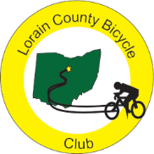
November 2023 Newsletter Red Flannel Month!

As we begin the second last month of the year, It is time to restock your cold weather kits and recommit to riding through the cold days. Our ride captain continues to lead this effort all while showing his sartorial splendor. He even applied new duct tape to his winter shoes. Remember that Tuesday and Thursday rides will begin at 11 A.M. in November.

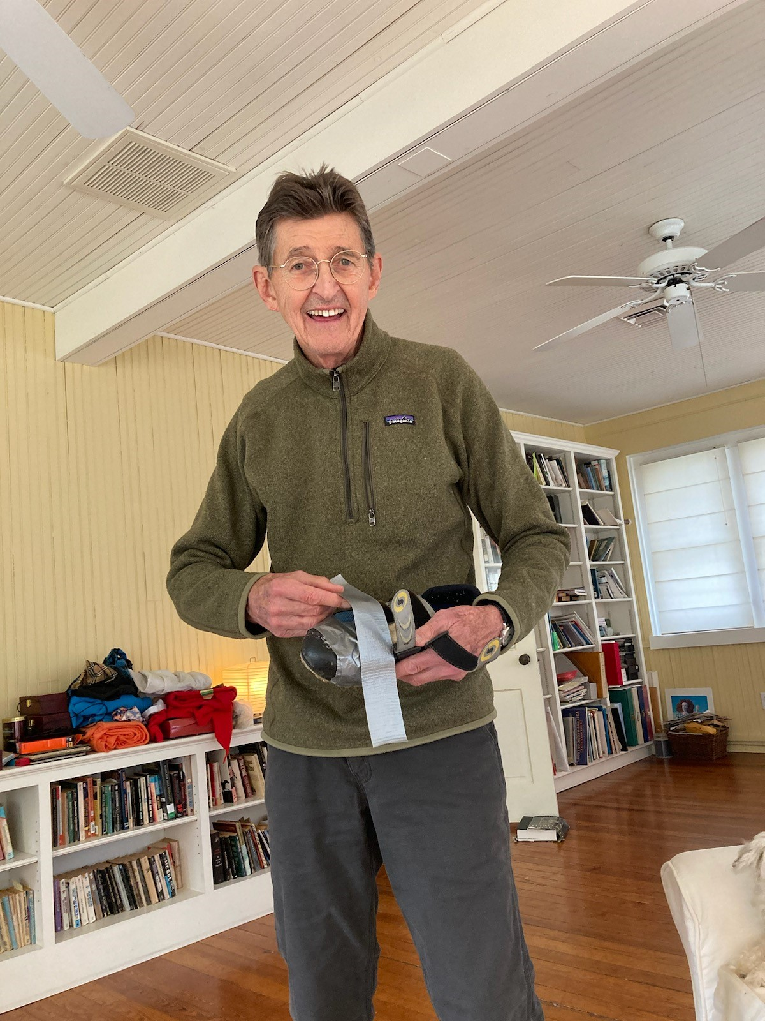

Karla and Denny ended the month in South Carolina riding the Hincapie. Jeff Stacklin was also there. Up north in Lorain County, there were quite a few rainy days and even more chilly ones. The staunch riders came out anyway. Now the month is ending with a few warm days.

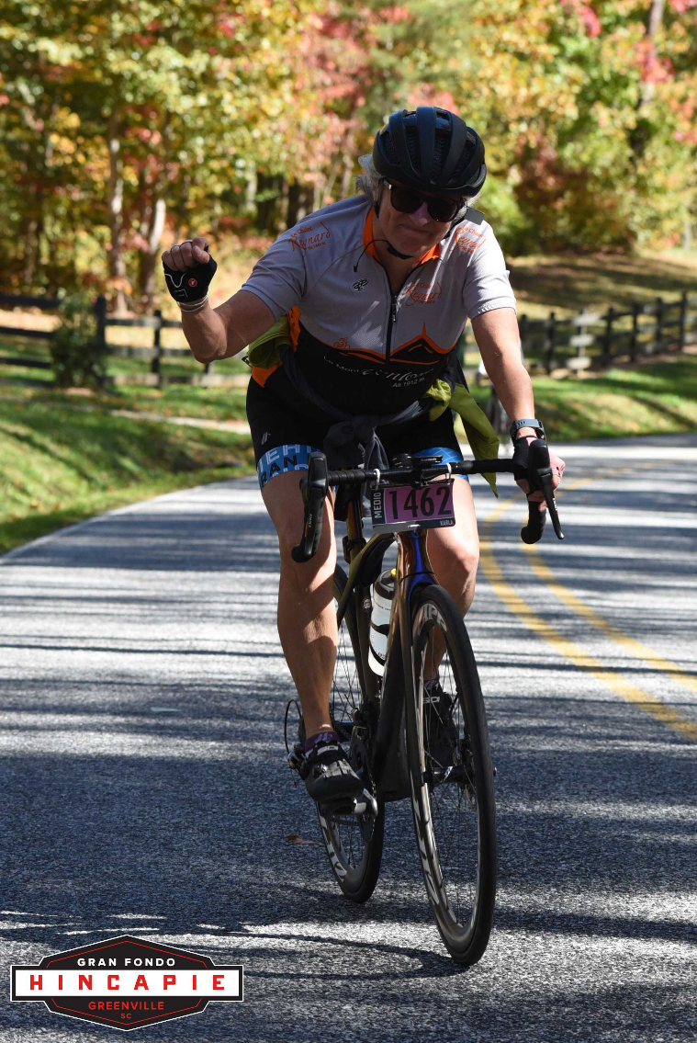
Denny and Karla on the Hincapie

Karen is doing a great job of getting the club ready for the Red Flannel. Clyde led a team of David, Steve, and Bill painting the road signs (our last year to paint arrows as most riders now have bike computers with GPS). Now we all need to make our chilis, soups, and cookies and then get the riders to come and enjoy the ride.

Lorain County Bicycle Club

 | November 2023
Sun | Mon | Tue | Wed | Thu | Fri | Sat
29 | 30 | 31 | November 1 | 2 | 3 | 4
9 am  U-show 32 miles. Start at Oberlin Gasholder Building, 291 South Main Street, Oberlin, OH 44074 |  | 9 am  30 miles. Start at Oberlin Gasholder Building, 291 South Main Street, Oberlin, OH 44074 |  | 11 am  30 miles. Start at Oberlin Gasholder Building, 291 South Main Street, Oberlin, OH 44074 |  | 9 am  U-show 32 miles. Start at Oberlin Gasholder Building, 291 South Main Street, Oberlin, OH 44074
5 | 6 | 7 | 8 | 9 | 10 | 11  Veterans Day
8 am  event: Red Flannel half or full metric century (31 or 62 miles). Start at The Lodge of New Russia Township, 46300 Butternut Ridge Rd, Oberlin, OH |  | 11 am  30 miles. Start at Oberlin Gasholder Building, 291 South Main Street, Oberlin, OH 44074 |  | 11 am  30 miles. Start at Oberlin Gasholder Building, 291 South Main Street, Oberlin, OH 44074 |  | 9 am  U-show 32 miles. Start at Oberlin Gasholder Building, 291 South Main Street, Oberlin, OH 44074
12 | 13 | 14 | 15 | 16 | 17 | 18
9 am  U-show 32 miles. Start at Oberlin Gasholder Building, 291 South Main Street, Oberlin, OH 44074 |  | 11 am  30 miles. Start at Oberlin Gasholder Building, 291 South Main Street, Oberlin, OH 44074 |  | 11 am  30 miles. Start at Oberlin Gasholder Building, 291 South Main Street, Oberlin, OH 44074 |  | 9 am  U-show 32 miles. Start at Oberlin Gasholder Building, 291 South Main Street, Oberlin, OH 44074
19 | 20 | 21 | 22 | 23  Thanksgiving Day | 24 | 25
9 am  U-show 32 miles. Start at Oberlin Gasholder Building, 291 South Main Street, Oberlin, OH 44074 |  | 11 am  30 miles. Start at Oberlin Gasholder Building, 291 South Main Street, Oberlin, OH 44074 |  | 11 am  30 miles. Start at Oberlin Gasholder Building, 291 South Main Street, Oberlin, OH 44074 |  | 9 am  U-show 32 miles. Start at Oberlin Gasholder Building, 291 South Main Street, Oberlin, OH 44074
26 | 27 | 28 | 29 | 30 | December 1 | 2
9 am  U-show 32 miles. Start at Oberlin Gasholder Building, 291 South Main Street, Oberlin, OH 44074 |  | 11 am  30 miles. Start at Oberlin Gasholder Building, 291 South Main Street, Oberlin, OH 44074 |  | 11 am  30 miles. Start at Oberlin Gasholder Building, 291 South Main Street, Oberlin, OH 44074 |  | 11 am  U-show 32 miles. Start at Oberlin Gasholder Building, 291 South Main Street, Oberlin, OH 44074

rides@loraincountybicycleclub.org - www.loraincountybicycleclub.org

Editor’s Note: My riding season is over as I got a pacemaker implanted last Friday. The procedure went well and now I have work through the healing process for the next 4-12 weeks. I do hope to see everyone at some of the starts.

