LCBC – Lorain County Bicycle Club 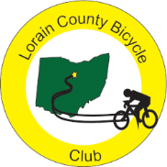
October 2023 Newsletter Sunday Rides begin at 9 A.M. on Oct. 1

It is hard to believe that we are beginning October. On September 19th, Karla called a club meeting to review the plans for our upcoming, November 5th, RED FLANNEL ride. Thirteen club members attended the meeting and everything seems in order for another successful ride. We will once again begin at the New Russia Township building. Our stop for the metric century loop will be in Milan. Members are encouraged to make chili, soup, and/or cookies for the riders. This home cooking is one of the elements that makes our RED FLANNEL ride special. Route painting will be done at the end of October and, if you want to help, Clyde will be heading up that aspect of the ride preparation. The other ride teams that are needed include registration, township hall food service, Milan food service, SAG services, supply purchasing, and cleanup. Everyone is needed for the end of the ride cleanup. If you are a member and don’t have another assignment, call Karen Hobbs to see how you can help. The other thing everyone can do is spread the word. Riding the Red Flannel is a great way to end the formal cycling season in Ohio. Invite your friends and area cyclists to join in this celebration of a great year of biking. With the 30 mile and the 62+ mile routes, there is a route for every level of rider. Riders looking for a totally flat route can opt to ride the trail out to Wakeman and back.

Special thanks to Ryke, Ralph, Paul, and others who alerted club members to the Shimano crank recall. Their timely notification and helpful instruction on how to check and how to get recourse helped a number of club members understand the recall and respond to it. A lot of us ride using Shimano components. (if you missed their posts, look at your September “all members” emails.)

September riding was decent but 2023 continued to be a year where many of us have dealt with life events that kept us off our bikes for extended periods of time. It is also harvest season where our routes take us among a lot of activity in the fields.
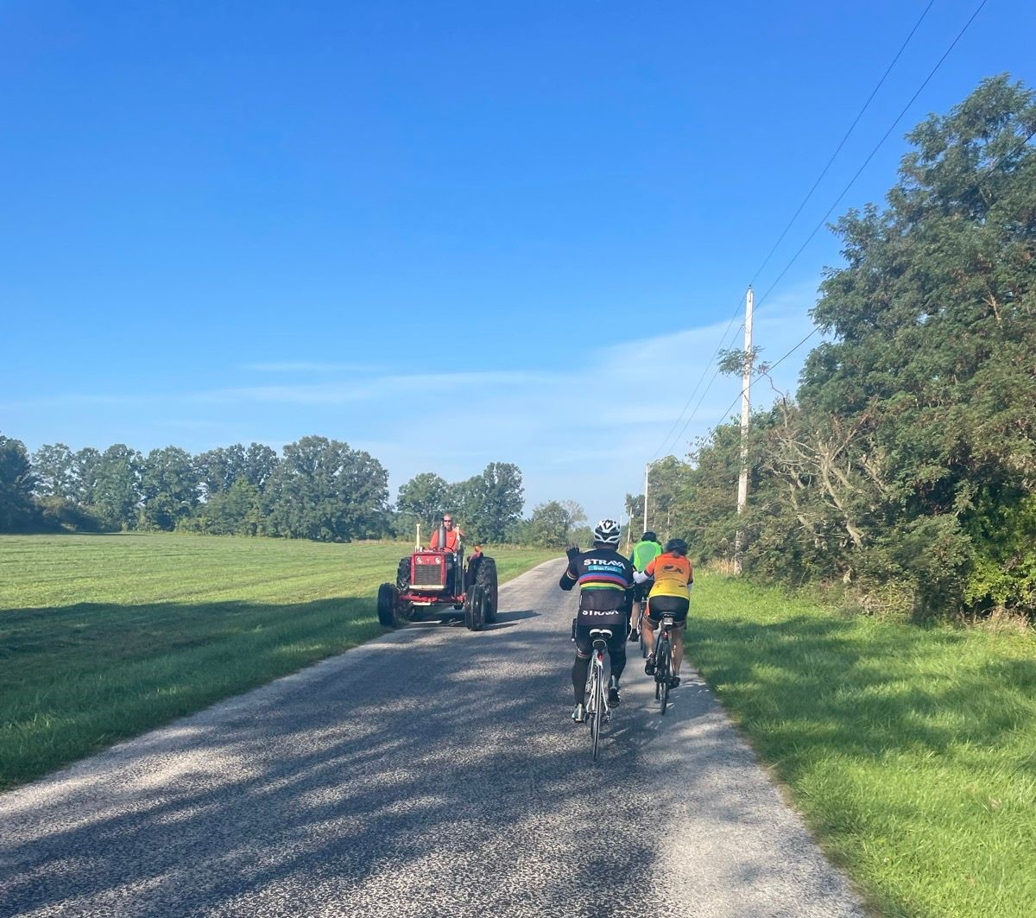

A President’s Corner contribution (or a summary of some ride starts)
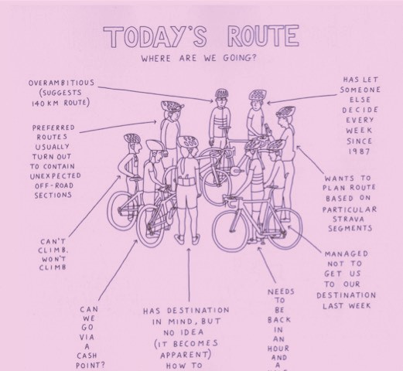

Note from Karen Hobbs, Red Flannel Coordinator

REMINDER - NOVEMBER 5TH - 49TH RED FLANNEL

We need workers for the Start/Finish at New Russia Township Hall.

Set up - Greeters - Give Directions and All Other Duties as needed.
Please raise your hand to work the Oberlin start.

Ron C has volunteered to be the SAG coordinator in Clyde's absence.
SAG drivers needed.

Food - we need soup makers
Chili, vegetable, vegan, or cookies.

Please let me know what you can work.

Thanks
Karen Hobbs
Red Flannel Coordinator
hobbs53@frontier.com
440-315-1607

Lorain County Bicycle Club

 | October 2023
Sun | Mon | Tue | Wed | Thu | Fri | Sat
October 1 | 2 | 3 | 4 | 5 | 6 | 7
9 am  Medina 58.6 miles. Start at Oberlin Gasholder Building, 291 South Main Street, Oberlin, OH 44074 |  | 9 am  30 miles. Start at Oberlin Gasholder Building, 291 South Main Street, Oberlin, OH 44074 |  | 9 am  30 miles. Start at Oberlin Gasholder Building, 291 South Main Street, Oberlin, OH 44074 |  | 9 am  U-show 32 miles. Start at Oberlin Gasholder Building, 291 South Main Street, Oberlin, OH 44074
8 | 9  Columbus Day | 10 | 11 | 12 | 13 | 14
9 am  U-show 32 miles. Start at Oberlin Gasholder Building, 291 South Main Street, Oberlin, OH 44074 |  | 9 am  30 miles. Start at Oberlin Gasholder Building, 291 South Main Street, Oberlin, OH 44074 |  | 9 am  30 miles. Start at Oberlin Gasholder Building, 291 South Main Street, Oberlin, OH 44074 |  | 9 am  U-show 32 miles. Start at Oberlin Gasholder Building, 291 South Main Street, Oberlin, OH 44074
15 | 16 | 17 | 18 | 19 | 20 | 21
9 am  U-show 32 miles. Start at Oberlin Gasholder Building, 291 South Main Street, Oberlin, OH 44074 |  | 9 am  30 miles. Start at Oberlin Gasholder Building, 291 South Main Street, Oberlin, OH 44074 |  | 9 am  30 miles. Start at Oberlin Gasholder Building, 291 South Main Street, Oberlin, OH 44074 |  | 9 am  U-show 32 miles. Start at Oberlin Gasholder Building, 291 South Main Street, Oberlin, OH 44074
22 | 23 | 24 | 25 | 26 | 27 | 28
9 am  U-show 32 miles. Start at Oberlin Gasholder Building, 291 South Main Street, Oberlin, OH 44074 |  | 9 am  30 miles. Start at Oberlin Gasholder Building, 291 South Main Street, Oberlin, OH 44074 |  | 9 am  30 miles. Start at Oberlin Gasholder Building, 291 South Main Street, Oberlin, OH 44074 |  | 9 am  U-show 32 miles. Start at Oberlin Gasholder Building, 291 South Main Street, Oberlin, OH 44074
29 | 30 | 31 | November 1 | 2 | 3 | 4
9 am  U-show 32 miles. Start at Oberlin Gasholder Building, 291 South Main Street, Oberlin, OH 44074 |  | 9 am  30 miles. Start at Oberlin Gasholder Building, 291 South Main Street, Oberlin, OH 44074 |  | 11 am  30 miles. Start at Oberlin Gasholder Building, 291 South Main Street, Oberlin, OH 44074 |  | 9 am  U-show 32 miles. Start at Oberlin Gasholder Building, 291 South Main Street, Oberlin, OH 44074

rides@loraincountybicycleclub.org - www.loraincountybicycleclub.org

